The Winners
The winners of the competitions staged as part of Night of the Cane have been as follows:
1999 - PVC Cat 

2000 - Miss Noire 

2001 - Ivan and Elisa

2002 - Richard and Leia 
2003 - Lucy Bailey 
2004 - Master El Diablo and slave C 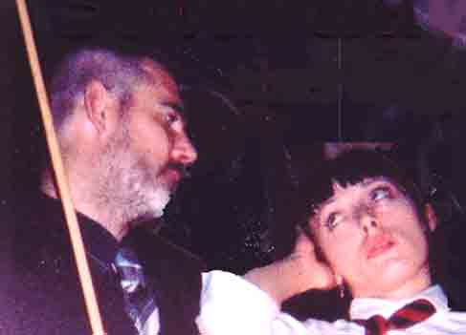
2005 - Master El Diablo and slave C
2006 - Master El Diablo and slave C
2007 - Mr Prendergast
2008 – Mr Jones
2009 – Mistress Switch 

